**OBSTACLES AS WELL AS POSSIBILITIES IN CHEST COUGH CLASSIFICATION AND TREATMENT WITH COMPUTER VISION APPROACHES**

*1B. Varshitha , 2G. Likhitha ,3 K. Akhil, 4Dr V. Janaki*

# *1,2,3bachelor Degree, Cse,* *Jayamukhi Institute Of Technological Sciences Narsampet, Warangal.*

*4Dr V.Janaki, Professor, bachelor Degree, Cse, Jayamukhi Institute Of Technological Sciences Narsampet, Warangal.*

**ABSTRACT:**

A typical sign of many respiratory illnesses is coughing. When diagnosing a condition, it might be helpful to take the sound and kind of cough into account. The danger of respiratory infections is very high. International human life together with a substantial economic crisis, especially in nations with few treatment resources. In this study, we looked at the newest proposed technology for reducing the effects of respiratory illnesses. In order to ensure people's wellbeing, artificially intelligent (AI), an exciting technology that assists in data analysis and outcome prediction.

We explained how cough symptoms may be accurately employed by AI algorithms to identify and classify a variety of recognised diseases, such as pneumonia, pulmonary oedema, asthma, bronchitis (TB), COVID19, pertussis or and other respiratory illnesses. We also determined which methods were most effective in detecting respiratory illnesses from cough samples. The most recent problems, possibilities, and difficulties in respiratory illness detection and diagnosis are discussed in this paper, enabling professionals and researchers to create more effective methods.

**INTRODUCTION:**

Malfunctioning lungs raise the risk of death and morbidity for the entire world's population. The danger is greater in underdeveloped nations where there is more pollution from manufacturing and inadequate air ventilation systems. Coughing is a frequent sign of several illnesses, including COVID-19, bronchitis, pertussis infection asthma, and bronchitis. Every respiratory ailment tends to have a different cough sound, making it possible for doctors to identify the sickness only by listening to the patient cough. various digital technology solutions as a result

that use big data analysis, the Internet of Things (IoT), Blockchain, algorithms based on artificial intelligence (also called AI) in the forms of machine learning (ML) and deep studying (DL), others were proposed to detect the infection from the sneeze sound [1]. Yizhang Jiang served as the associate editor overseeing the evaluation of this manuscript and approving it for publication. Additionally, the healthcare sector is using AI more and more to aid doctors in the diagnosis and prognosis of a wide range of illnesses [2], particularly in the recent past where the COVID-19 virus became an epidemic and there weren't enough hospitals to adequately care for those ill [3]. It is crucial to create practical and affordable technology to manage respiratory disorders because of their potentially lethal effects.

Healthcare technology have a significant impact on improving healthcare, according to the World Health Organisation (WHO). therapy of various respiratory conditions. The most promising technology, AI, has the potential to completely alter how diseases are diagnosed and detected in the future [4].

A number of review articles conducted a feasibility study on the use of technology in the control and management of sickness, such as [5], which reviewed various research regarding efficient instruments for detecting and treating diseases at a reasonable cost from 55 papers.

They said low-cost tools including mobile applications, texting/SMS, and wearable technology had demonstrated their viability in identifying various respiratory disorders. Moreover, Amrulloh et al. [6] examined the AI methods for diagnosing asthma illness. According to the report, the most popular AI techniques for detecting asthma are neural networks (ANN), The Tree of Decisions (DT), and Random Forest (RF). Similar to this, Anand et al. [7] examined the most recent technologies used to counter COVID-19 on various scales. The survey revealed how technology assisted medical professionals in tracking COVID-19 infection hotspots, image processing, and selecting the optimal treatment option based on patient data analysis. Additionally, Bales et al. [8] had studied the four stages of COVID-19 and claimed that the economic effects of the worldwide epidemic included a decline in the tourism sector in contrast to a rise in the food and telecommunications industries and a decrease in transit use as a result of the government shutdown. Additionally, Belkacem et al. [9] provided an overview of the hospitals technological resources and explained how AI and big data were recommended solutions to combat the COVID-19 pandemic. They stated that due to its affordability, computed tomography, also known as CT, and X-ray pictures are the most employed image scanner methods.

In order to build a database for identifying and treating the illness, Shuja et al. [10] reviewed the most pertinent publications that used algorithms to analyse COVID-19 from CT-scan images, cough sounds, and x-rays.

Additionally, they compared the pertinent studies, identified challenges, and suggested directions for the field's future. To safeguard frontline staff and find a means to preserve the privacy of the patients who contributed their data, they advised that the majority of healthcare professionals utilise technologies like picture scans and cough noise evaluation via applications. Deshpande and Schuller [11] reviewed a number of ML/DL methods that were used to audio analysis in order to identify the COVID-19 illness. To automate the contact with physiological researchers for crucial illness analysis, they summarised the COVID-19 diagnostic procedures and separated them into cough detection methods, breathing analysis, chest x-ray, and popular chat-pots. They also talked about the most recent government monitoring initiatives taken to combat the illness and support medical professionals in providing care while upholding social distance standards. Similar to this, Lella and Alphonse [12] assessed the most recent method that employed sound analysis to distinguish COVID-19 from various respiratory noises including cough, breathing, and voice. . It claimed that using AI to diagnose COVID-19 is trustworthy and efficient and encouraged more study into the use of AI in this area. They advocated Data De-noising Auto Encoder (DDAE) to construct an efficient COVID-19 breathing sound diagnostic tool and a CNN to analyse data sharing. instrument for diagnosing sound.

None of the polls particularly addressed the based on artificial intelligence cough detection approach, but the majority of them explored AI-based detection and evaluation techniques based on other vital indicators. Furthermore, given that cough detection and diagnostic software is affordable and has the potential to enhance healthcare practises, the field's difficulties and prospects in this particular area need to be updated. We produced a survey article to address the shortcomings of the earlier publications in response to this demand. The following are the main contributions that this scoping survey article makes:

• Describe the traits of the illnesses and their signs and symptoms.

• Summarise the most recent techniques for diagnosing cough sounds and locating the associated respiratory illness.

• Make a table that compares the level of sensitivity, accuracy, F1-score, and accuracy of the many diagnosing methods.

• Examine the newest techniques for identifying cough sounds and identifying lung illness.

Emphasise the field's difficulties and prospects.

The essay is set up like follows: The technique is illustrated in Section 2, and numerous characteristics and symptoms of cough are presented in Section 3. The methods for diagnosing and detecting coughs are presented in Section 4. The most effective and popular AI algorithms utilised in the majority of relevant articles are discussed in Section 5, along with the potential and problems facing the cough-based detection and diagnosis business. Finally, Section 6 contains the paper's conclusion.

**RELATED DATA:**

In order to enable doctors and technology developers create efficient and effective methods to detect the illness kind, it is crucial to be aware of the symptoms of respiratory infections. We discuss several respiratory conditions, their associated symptoms, and a comparison of them in the subsections that follow.

First of all, compared to young individuals, children and old adults over the age of 50 are more likely to get pneumonia, a lung condition. Men are also more likely than women to have it.

Acute cough, hard living vibrates, rapid breathing, tachycardia, and fever are just a few of the symptoms that might differ from person to person [13].

Children may have rib (chest) tightness, breathing problems, wheezing or snoring, the flu or a runny nose, diarrhoea, vomiting, and fever. Chest tightness is a sign of both bronchitis and asthma [14].

Second, untreated pulmonary illness can result in heart failure and mortality [15], [16]. It is an uncommon chronic respiratory disease that is brought on by the growth of tiny arteries in the lung. Shortness of breath, exhaustion, depression, swelling in the ankles, legs, and hands, an irregular heartbeat, chest pain, headache, dizziness, and dry coughing are just a few of its numerous lethal signs [17].

Thirdly, tuberculosis (TB) caused a significant number of casualties in the country of Indonesia, which has the fifth-highest rate of mortality worldwide [18]. Rapid genomic acid-amplification testing is used to diagnose it and look at the genetic makeup of the virus's protein. Due to swelling and obstruction of the airways, it causes bloody are coughing, night sweats, a high temperature, decreased appetite, and persistent cough [19].

Fourth, pneumonia is an obstructive lung illness that has a wide range of effects on its sufferers. Its primary sign is a wheezing cough, which is followed by symptoms such as pulmonary hyperventilation, dyspnea, asthma attack, change in birth weight, & fever [20]. Other fatigues also depended on restrictions in daily activities, tightening of the chest, including vertigo [21], [22]. Fifthly, the major symptoms of bronchitis, which is connected to COPD, are a cough and mucus production. It is an extremely dangerous condition that, if left untreated, may result in death through airflow obstruction [23].

Sixth, the polymerase chain reaction, and serology are used to diagnose the respiratory illness pertussis. Three stages make up this condition: catarrhal, paroxysmal, and convalescent. Whooping sound, fever, cough, cyanosis, red cheeks, swollen eyes, and nausea are some of its signs [24], [25]. Last but not least, COVID-19 is an acute respiratory infection that shares clinical traits with various organ dysfunction disorders (MODS) and acute respiratory distress syndrome (ARDS). The signs of it include a fever, coughing that is dry, fatigue, phlegm, throat irritation, dizziness, pain, and hard breathing. Less often seen symptoms include nausea, runny nose, bloody cough, diarrhoea, and conjunctival congestion. In addition, untreated lung or heart disease in older smokers might result in significant side effects such blue lips or face, ARDS, abrupt cardiac damage, and secondary infection. Elderly adults over 60 or those who have a medical condition like diabetes, high blood pressure, asthma, or heart disease are the most susceptible to contracting this disease. [26] Therefore, in order to enhance illness prevention and control, researchers must examine the causes and the required technology. Based on the research provided, Table 1 lists the typical symptoms for respiratory disorders. It's also not necessary for all patients to exhibit every symptom.

The association between the selected characteristic and the condition in the table shows that it is one for its signs that has been recognised as important in research on based on artificial intelligence diagnostics of respiratory disorders.

**EXISTING SYSTEM:**

The lungs are important organs in the respiratory system and used for gas exchange (oxygen and carbon dioxide). When we breathe. Our lungs transfer oxygen from the air into the blood, and carbon dioxide from the blood into the air. Cough is the most common symptom of several respiratory diseases. Cough is a defence mechanism of the body which prevents the respiratory tract from inhaling foreign materials accidentally or those produced internally by infection, it is characterized as wet when the sounds carry features indicative of mucus; in the absence of perceivable wetness, it is called dry. Changes in the character of the cough sound can reflect pathological situations in the lungs. Pathological situations arise due to some conditions like obstruction, restriction, and combined patterns

**PROPOSED SYSTEM:**

In this project we are using respiratory audio data-set to predict various diseases such as Asthma, Pneumonia, Bronchitis and many more. To implement this project, we have taken disease diagnosis data-set and respiratory audio data-set and then extract features from all audio data-set and then trained a convolution neural network (CNN) algorithm model. After training model, we can upload any new test data to predict disease from it.

**RESULT:**

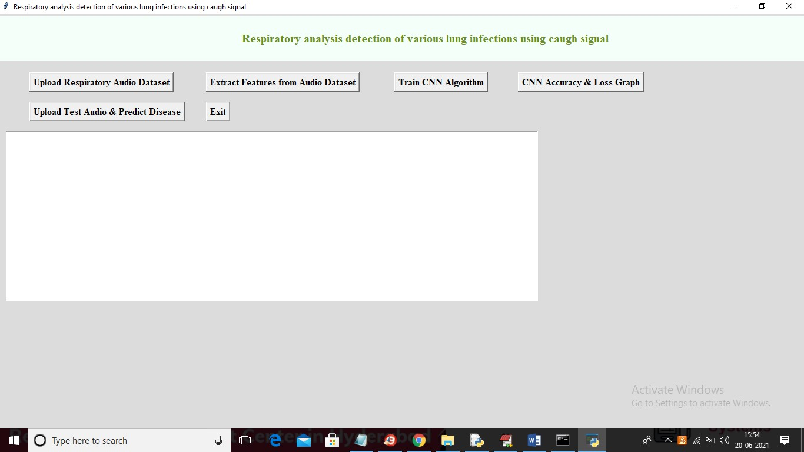



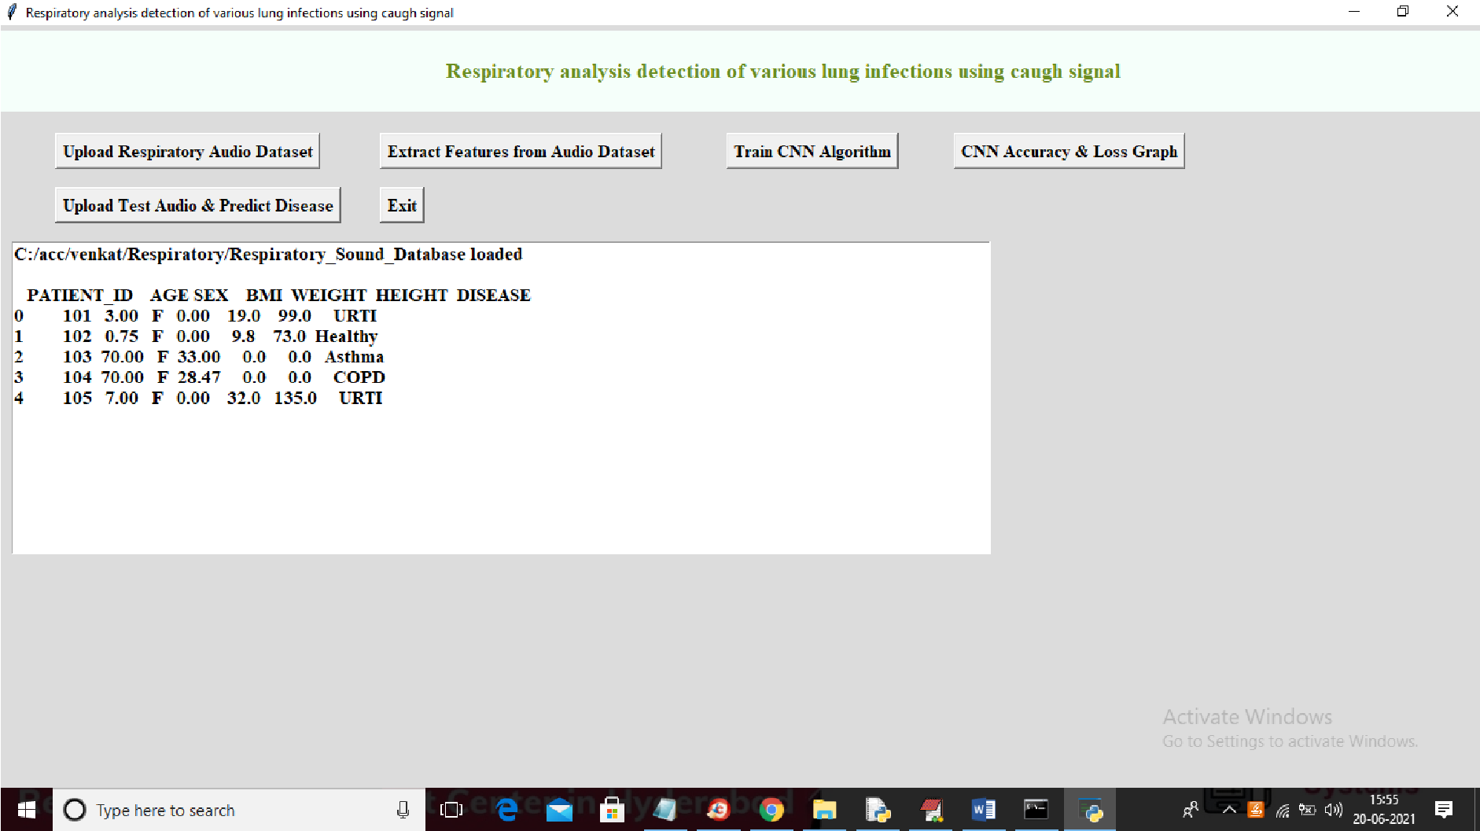

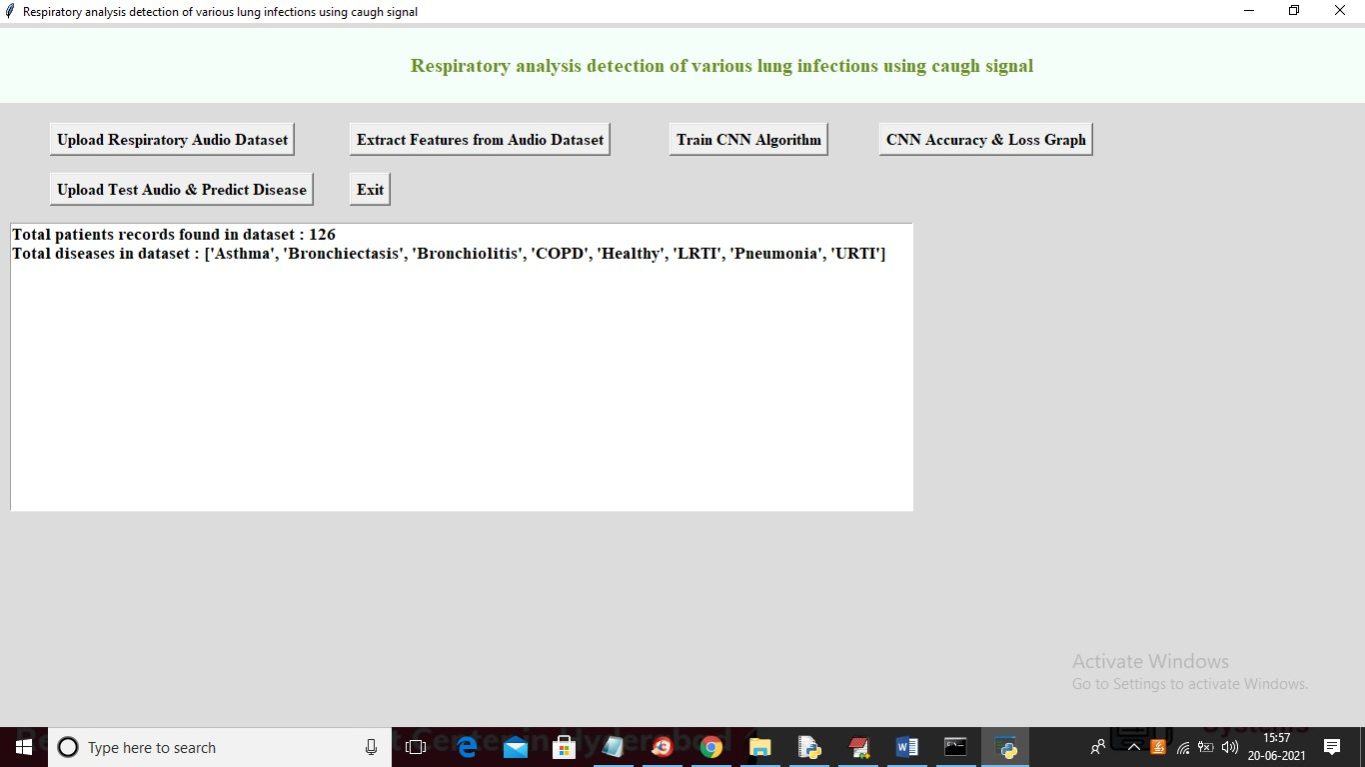

**CONCLUSION:**

This essay aimed to present a thorough analysis of the significant contributions made by a variety of front-line workers in hospitals, clinics, and labs as well as by researchers and scientists. Through the use of algorithms that use deep learning and the basics of speech recognition technology (ASR), AI implementation has significantly advanced the field of digital health. In this work, we reviewed numerous techniques for separating cough noises from other cough noises, including DNN, RNN, artificial neural network (ANN and k-NN.

To distinguish between studies that tested their algorithms on additional datasets, we developed a taxonomy. According to our data, ANN is more commonly employed than RF and DNN, while SVM classifier and LR are the most popular techniques for detecting and diagnosing respiratory disorders.

Additionally, we spoke about some of the problems facing the industry, as well as possible fixes and suggestions for interested parties looking to expand and finance the medical technology sector. We plan to investigate how to quickly identify more serious illnesses and stop their propagation in the future using big data analytics tools and AI techniques.

**REFERENCES:**

[1] U. R. Abeyratne, V. Swarnkar, A. Setyati, and R. Triasih, ‘‘Cough sound analysis can rapidly diagnose childhood pneumonia,’’ Ann. Biomed. Eng., vol. 41, no. 11, pp. 2448–2462, Nov. 2013, doi: 10.1007/ s10439-013-0836-0.

[2] R. X. A. Pramono, S. A. Imtiaz, and E. Rodriguez-Villegas, ‘‘Automatic identification of cough events from acoustic signals,’’ in Proc. 41st Annu. Int. Conf. IEEE Eng. Med. Biol. Soc. (EMBC), Jul. 2019, pp. 217–220, doi: 10.1109/EMBC.2019.8856420.

[3] T. Ahmed, M. Y. Ahmed, M. M. Rahman, E. Nemati, B. Islam, K. Vatanparvar, V. Nathan, D. McCaffrey, J. Kuang, and J. A. Gao, ‘‘Automated time synchronization of cough events from multimodal sensors in mobile devices,’’ in Proc. Int. Conf. Multimodal Interact., Oct. 2020, pp. 614–619, doi: 10.1145/3382507.3418855.

[4] M. Al-Khassaweneh and R. B. Abdelrahman, ‘‘A signal processing approach for the diagnosis of asthma from cough sounds,’’ J. Med. Eng. Technol., vol. 37, no. 3, pp. 165–171, Apr. 2013.

[5] J. Amoh and K. Odame, ‘‘Deep neural networks for identifying cough sounds,’’ IEEE Trans. Biomed. Circuits Syst., vol. 10, no. 5, pp. 1003–1011, Oct. 2016, doi: 10.1109/TBCAS.2016.2598794.

[6] Y. Amrulloh, U. Abeyratne, V. Swarnkar, and R. Triasih, ‘‘Cough sound analysis for pneumonia and asthma classification in pediatric population,’’ in Proc. 6th Int. Conf. Intell. Syst., Modelling Simulation, Feb. 2015, pp. 127–131, doi: 10.1109/ISMS.2015.41.

[7] A. Anand, D. Chamberlain, R. Kodgule, and R. R. Fletcher, ‘‘Pulmonary screener: A mobile phone screening tool for pulmonary and respiratory disease,’’ in Proc. IEEE Global Humanitarian Technol. Conf. (GHTC), Oct. 2018, pp. 1–7, doi: 10.1109/GHTC.2018.8601821.

[8] C. Bales, M. Nabeel, C. N. John, U. Masood, H. N. Qureshi, H. Farooq, I. Posokhova, and A. Imran, ‘‘Can machine learning be used to recognize and diagnose coughs?’’ in Proc. Int. Conf. e-Health Bioeng. (EHB), Oct. 2020, pp. 1–4.

[9] A. N. Belkacem, S. Ouhbi, A. Lakas, E. Benkhelifa, and C. Chen, ‘‘Endto-end AI-based point-of-care diagnosis system for classifying respiratory illnesses and early detection of COVID-19,’’ 2020, arXiv:2006.15469. [Online]. Available: <http://arxiv.org/abs/2006.15469>

[10] J. Shuja, E. Alanazi, W. Alasmary, and A. Alashaikh, ‘‘COVID-19 open source data sets: A comprehensive survey,’’ Int. J. Speech Technol., vol. 51, no. 3, pp. 1296–1325, Mar. 2021, doi: 10.1007/s10489-020-01862-6.

[11] G. Deshpande and B. Schuller, ‘‘An overview on audio, signal, speech, & language processing for COVID-19,’’ 2020, arXiv:2005.08579. [Online]. Available: <https://arxiv.org/abs/2005.08579>

[12] K. K. Lella and A. Pja, ‘‘A literature review on COVID-19 disease diagnosis from respiratory sound data,’’ AIMS Bioeng., vol. 8, no. 2, pp. 140–153, 2021.

[13] M. Binnekamp, K. J. van Stralen, L. den Boer, and M. A. van Houten, ‘‘Typical RSV cough: Myth or reality? A diagnostic accuracy study,’’ Eur. J. Pediatrics, vol. 180, no. 1, pp. 57–62, Jan. 2021, doi: 10.1007/ s00431-020-03709-1.

[14] G. H. R. Botha, G. Theron, R. M. Warren, M. Klopper, K. Dheda, P. D. Van Helden, and T. R. Niesler, ‘‘Detection of tuberculosis by automatic cough sound analysis,’’ Physiol. Meas., vol. 39, no. 4, p. 45005, 2018.

[15] Center for Disease Control and Prevention (CDC), Pertussis in Other Countries, 2019. [Online]. Available: https://www.cdc.gov/pertussis/ countries/index.html

[16] Centers for Disease Control Prevention, ‘‘Underlying cause of death 1999-2019,’’ CDC WONDER Online Database, Centers for Disease Control and Prevention, Atlanta, GA, USA, 2020. [Online]. Available: <https://wonder.cdc.gov/ucd-icd10.html>

[17] V. Chamola, V. Hassija, V. Gupta, and M. Guizani, ‘‘A comprehensive review of the COVID-19 pandemic and the role of IoT, drones, AI, blockchain, and 5G in managing its impact,’’ IEEE Access, vol. 8, pp. 90225–90265, 2020, doi: 10.1109/ACCESS.2020.2992341.

[18] S. Chatterjee, M. M. Rahman, T. Ahmed, N. Saleheen, E. Nemati, V. Nathan, K. Vatanparvar, and J. Kuang, ‘‘Assessing severity of pulmonary obstruction from respiration phase-based wheeze-sensing using mobile sensors,’’ in Proc. CHI Conf. Hum. Factors Comput. Syst., Apr. 2020, pp. 1–13, doi: 10.1145/3313831.3376444.

[19] P. B. Cornia and B. A. Lipsky, ‘‘Symptoms associated with pertussis are insufficient to rule in or rule out the diagnosis,’’ Chest, vol. 155, no. 2, pp. 449–450, Feb. 2019, doi: 10.1016/j.chest.2018.10.028.

[20] B. Dadonaite and M. Roser, ‘‘Pneumonia,’’ Our World in Data, 2018. [Online]. Available: <https://ourworldindata.org/pneumonia>

[21] T. Dubnov, ‘‘Signal analysis and classification of audio samples from individuals diagnosed with COVID-19,’’ M.S. thesis, Univ. California, San Diego, CA, USA, 2020.

[22] T. Eidlitz-Markus, M. Mimouni, and A. Zeharia, ‘‘Pertussis symptoms in adolescents and children versus infants: The influence of vaccination and age,’’ Clin. Pediatrics, vol. 46, no. 8, pp. 718–723, Oct. 2007, doi: 10.1177/0009922807302093.

[23] S. Ekins, J. S. Freundlich, A. M. Clark, M. Anantpadma, R. A. Davey, and P. Madrid, ‘‘Machine learning models identify molecules active against the Ebola virus in vitro,’’ FResearch, vol. 4, p. 1091, Jan. 2016, doi: 10.12688/f1000research.7217.2.

[24] L. E. Ellington, R. H. Gilman, J. M. Tielsch, M. Steinhoff, D. Figueroa, S. Rodriguez, B. Caffo, B. Tracey, M. Elhilali, J. West, and W. Checkley, ‘‘Computerised lung sound analysis to improve the specificity of paediatric pneumonia diagnosis in resource-poor settings: Protocol and methods for an observational study,’’ BMJ Open, vol. 2, no. 1, 2012, Art. no. e000506, doi: 10.1136/bmjopen-2011-000506.

[25] E. Elveren and N. Yumuşak, ‘‘Tuberculosis disease diagnosis using artificial neural network trained with genetic algorithm,’’ J. Med. Syst., vol. 35, no. 3, pp. 329–332, Jun. 2011, doi: 10.1007/s10916-009-9369-3.

[26] K. P. Exarchos, M. Beltsiou, C.-A. Votti, and K. Kostikas, ‘‘Artificial intelligence techniques in asthma: A systematic review and critical appraisal of the existing literature,’’ Eur. Respiratory J., vol. 56, no. 3, Sep. 2020, Art. no. 2000521, doi: 10.1183/13993003.00521-2020.

[27] G. E. Iyawa, C. O. Ondiek, and J. O. Osakwe, ‘‘MHealth: A lowcost approach for effective disease diagnosis, prediction, monitoring and management–effective disease diagnosis,’’ in Smart Medical Data Sensing and IoT Systems Design in Healthcare, C. Chakraborty, Ed. Hershey, PA, USA: IGI Global, 2020, pp. 1–21.

[28] Y. Kanemitsu, H. Matsumoto, N. Osman, T. Oguma, T. Nagasaki, Y. Izuhara, I. Ito, T. Tajiri, T. Iwata, A. Niimi, and M. Mishima, ‘‘‘Cold air’ and/or ‘talking’ as cough triggers, a sign for the diagnosis of cough variant asthma,’’ Respiratory Invest., vol. 54, no. 6, pp. 413–418, 2016, doi: 10.1016/j.resinv.2016.07.002.

[29] S. Khomsay, R. Vanijjirattikhan, and J. Suwatthikul, ‘‘Cough detection using PCA and deep learning,’’ in Proc. Int. Conf. Inf. Commun. Technol. Converg. (ICTC), Oct. 2019, pp. 101–106, doi: 10.1109/ICTC46691.2019.8939769.

[30] H. Kim, G. Han, and J.-H. Song, ‘‘A review for artificial intelligence proving to fight against COVID-19 pandemic and prefatory health policy,’’ J. Med. Biomed. Appl. Sci., vol. 8, no. 8, pp. 494–506, 2020, doi: 10.15520/jmbas.v8i8.247.

[31] J. M. Kline, W. D. Lewis, E. A. Smith, L. R. Tracy, and S. K. Moerschel, ‘‘Pertussis: A reemerging infection,’’ Amer. Family Physician, vol. 88, no. 8, pp. 507–514, Oct. 2013.

[32] K. Kosasih, U. R. Abeyratne, V. Swarnkar, and R. Triasih, ‘‘Wavelet augmented cough analysis for rapid childhood pneumonia diagnosis,’’ IEEE Trans. Biomed. Eng., vol. 62, no. 4, pp. 1185–1194, Apr. 2015, doi: 10.1109/TBME.2014.2381214.

[33] Kumar, K. Abhishek, M. R. Ghalib, P. Nerurkar, K. Shah, M. Chandane, S. Bhirud, D. Patel, and Y. Busnel, ‘‘Towards cough sound analysis using the Internet of Things and deep learning for pulmonary disease prediction,’’ Trans. Emerg. Telecommun. Technol., p. e4184, Dec. 2020. [Online]. Available: https://onlinelibrary.wiley.com/doi/abs/10.1002/ett.4184, doi: 10.1002/ett.4184.

[34] J. Monge-Álvarez, C. Hoyos-Barceló, L. M. San-José-Revuelta, and P. Casaseca-de-la-Higuera, ‘‘A machine hearing system for robust cough detection based on a high-level representation of band-specific audio features,’’ IEEE Trans. Biomed. Eng., vol. 66, no. 8, pp. 2319–2330, Aug. 2019, doi: 10.1109/TBME.2018.2888998.

[35] J. Laguarta, F. Hueto, and B. Subirana, ‘‘COVID-19 artificial intelligence diagnosis using only cough recordings,’’ IEEE Open J. Eng. Med. Biol., vol. 1, pp. 275–281, 2020, doi: 10.1109/OJEMB.2020. 3026928.

[36] C. K. W. Lai, R. Beasley, J. Crane, S. Foliaki, J. Shah, and S. Weiland, ‘‘Global variation in the prevalence and severity of asthma symptoms: Phase three of the international study of asthma and allergies in childhood (ISAAC),’’ Thorax, vol. 64, no. 6, pp. 476–483, 2009, doi: 10.1136/thx.2008.106609.

[37] S. Larson, G. Comina, R. H. Gilman, B. H. Tracey, M. Bravard, and J. W. López, ‘‘Validation of an automated cough detection algorithm for tracking recovery of pulmonary tuberculosis patients,’’ PLoS ONE, vol. 7, no. 10, pp. 1–10, 2012, doi: 10.1371/journal.pone.0046229.

[38] J. A. Lewnard and N. C. Lo, ‘‘Scientific and ethical basis for socialdistancing interventions against COVID-19,’’ Lancet Infect. Dis., vol. 20, no. 6, pp. 631–633, 2020, doi: 10.1016/S1473-3099(20)30190-0.

[39] J.-M. Liu, M. You, Z. Wang, G.-Z. Li, X. Xu, and Z. Qiu, ‘‘Cough detection using deep neural networks,’’ in Proc. IEEE Int. Conf. Bioinf. Biomed. (BIBM), Nov. 2014, pp. 560–563, doi: 10.1109/BIBM.2014. 6999220.

[40] T. Lytras, M. Kogevinas, H. Kromhout, A.-E. Carsin, J. M. Antó, H. Bentouhami, J. Weyler, J. Heinrich, D. Nowak, I. Urrutia, and J. Martínez-Moratalla, ‘‘Occupational exposures and incidence of chronic bronchitis and related symptoms over two decades: The European community respiratory health survey,’’ Occupat. Environ. Med., vol. 76, no. 4, pp. 222–229, 2019, doi: 10.1136/oemed-2018-105274.

[41] H. S. Maghded, K. Z. Ghafoor, A. S. Sadiq, K. Curran, D. B. Rawat, and K. Rabie, ‘‘A novel AI-enabled framework to diagnose coronavirus COVID-19 using smartphone embedded sensors: Design study,’’ in Proc. IEEE 21st Int. Conf. Inf. Reuse Integr. Data Sci. (IRI), Aug. 2020, pp. 180–187, doi: 10.1109/IRI49571.2020.00033. VOLUME 9, 2021 102341 K. S. Alqudaihi et al.: Cough Sound Detection and Diagnosis Using AI Techniques

[42] S. Matos, S. S. Birring, I. D. Pavord, and D. H. Evans, ‘‘Detection of cough signals in continuous audio recordings using hidden Markov models,’’ IEEE Trans. Biomed. Eng., vol. 53, no. 6, pp. 1078–1083, Jun. 2006, doi: 10.1109/TBME.2006.873548.

[43] D. McCollister, S. Shaffer, D. B. Badesch, A. Filusch, E. Hunsche, R. Schüler, I. Wiklund, and A. Peacock, ‘‘Development of the pulmonary arterial hypertension-symptoms and impact (PAH-SYMPACT) questionnaire: A new patient-reported outcome instrument for PAH,’’ Respiratory Res., vol. 17, no. 1, pp. 1–12, Dec. 2016, doi: 10.1186/s12931-016-0388-6.

[44] F. Muro, J. Meta, J. Renju, A. Mushi, H. Mbakilwa, R. Olomi, H. Reyburn, and H. Hildenwall, ‘‘‘It is good to take her early to the doctor’—Mothers’ understanding of childhood pneumonia symptoms and health care seeking in Kilimanjaro region, Tanzania,’’ BMC Int. Health Hum. Rights, vol. 17, no. 1, p. 27, Dec. 2017, doi: 10.1186/s12914-017-0135-1.

[45] N. W. Morrell, S. Adnot, S. L. Archer, J. Dupuis, P. L. Jones, M. R. MacLean, I. F. McMurtry, K. R. Stenmark, P. A. Thistlethwaite, N. Weissmann, J. X.-J. Yuan, and E. K. Weir, ‘‘Cellular and molecular basis of pulmonary arterial hypertension,’’ J. Amer. College Cardiol., vol. 54, no. 1, pp. S20–S31, 2009.

[46] K. Vatanparvar, E. Nemati, V. Nathan, M. M. Rahman, and J. Kuang, ‘‘CoughMatch—Subject verification using cough for personal passive health monitoring,’’ in Proc. 42nd Annu. Int. Conf. IEEE Eng. Med. Biol. Soc. (EMBC), Jul. 2020, pp. 5689–5695, doi: 10.1109/EMBC44109.2020.9176835.

[47] E. Nemati, M. M. Rahman, V. Nathan, K. Vatanparvar, and J. Kuang, ‘‘Poster abstract: A comprehensive approach for cough type detection,’’ in Proc. IEEE/ACM Int. Conf. Connected Health, Appl., Syst. Eng. Technol. (CHASE), Sep. 2019, pp. 15–16, doi: 10.1109/CHASE48038.2019.00013.

[48] J. Monge-Álvarez, C. Hoyos-Barceló, K. Dahal, and P. Casaseca-de-la-Higuera, ‘‘Audio-cough event detection based on moment theory,’’ Appl. Acoust., vol. 135, pp. 124–135, Jun. 2018, doi: 10.1016/j.apacoust.2018.02.001.

[49] U. Ozkaya, S. Ozturk, and M. Barstugan, ‘‘Coronavirus (COVID-19) classification using deep features fusion and ranking technique,’’ 2020, arXiv:2004.03698. [Online]. Available: <http://arxiv.org/abs/2004.03698>

[50] M. Pahar, M. Klopper, R. Warren, and T. Niesler, ‘‘COVID19 cough classification using machine learning and global smartphone recordings,’’ 2020, arXiv:2012.01926. [Online]. Available: <http://arxiv.org/abs/2012.01926>

[51] A. Pal and M. Sankarasubbu, ‘‘Pay attention to the cough: Early diagnosis of COVID-19 using interpretable symptoms embeddings with cough sound signal processing,’’ 2020, arXiv:2010.02417. [Online]. Available: <http://arxiv.org/abs/2010.02417>

[52] A. M. Pescatore, C. M. Dogaru, L. Duembgen, M. Silverman, E. A. Gaillard, B. D. Spycher, and C. E. Kuehni, ‘‘A simple asthma prediction tool for preschool children with wheeze or cough,’’ J. Allergy Clin. Immunol., vol. 133, no. 1, pp. 111.e13–118.e13, 2014, doi: 10.1016/j.jaci.2013.06.002.

[53] Q. Pham, D. C. Nguyen, T. Huynh-The, W. Hwang, and P. N. Pathirana, ‘‘Artificial intelligence (AI) and big data for coronavirus (COVID-19) pandemic: A survey on the state-of-the-arts,’’ IEEE Access, vol. 8, pp. 130820–130839, 2020, doi: 10.1109/ACCESS.2020.3009328.

[54] T. H. Pingale and H. T. Patil, ‘‘Analysis of cough sound for pneumonia detection using wavelet transform and statistical parameters,’’ in Proc. Int. Conf. Comput., Commun., Control Automat. (ICCUBEA), Aug. 2017, pp. 1–6, doi: 10.1109/ICCUBEA.2017.8463900.

[55] G. Pinkas, Y. Karny, A. Malachi, G. Barkai, G. Bachar, and V. Aharonson, ‘‘SARS-CoV-2 detection from voice,’’ IEEE Open J. Eng. Med. Biol., vol. 1, pp. 268–274, 2020, doi: 10.1109/OJEMB.2020.3026468.